**DAILY ONLINE ACTIVITIES SUMMARY**

|  |  |  |  |  |  |  |  |
| --- | --- | --- | --- | --- | --- | --- | --- |
| **Date:** | | **2/6/2020** | | | | | |
| **Name of the Faculty** | | **REENA LOBO** | | | | | |
| **No. of Students Allotted for monitoring** | | | | | **19** | | |
| **Progress** | | | | | **GOOD** | | |
| **Whether collected report from all the allotted students** | | | | | **18,NOT SUBMITTED RAMITHA** | | |
| **Online Test Summary** | | | | | | | |
| **Subject** |  | | | | | | |
| **Semester** |  | | | **Duration** | |  | |
| **No. of students Taken** | | |  | **Passing %** | |  | |
| **Certification Course Summary** | | | | | | | |
| **Course** | | 1. Attended webinar on python for data scienceCertification provider: sacred heart collegeDURATION: 2 hour2. Completed RPA courseCERTIFICATION PROVIDER: ui pathDuration: 3hrs | | | | | |
| **Certificate Provider** | |  | | | **Duration** | |  |
| **Coding Challenges** | | | | | | | |
| **Write a program in java, an array of integer data to be initialized. During the initialization, if a user enters a value other than integer value, then it will throw InputMismatchException exception. On the occurrence of such an exception, your program should print “You entered bad data.” If there is no such exception it will print the total sum of the array.** | | | | | | | |
| **Status: COMPLETED** | | | | | | | |
| **Uploaded the report in Github** | | | | | **yes** | | |
| **If yes Repository name** | | | | | <https://github.com/reenalobo/ONLINE-ACTIVITY-REPORT/upload/master> | | |
| **Uploaded the report in slack** | | | | | **yes** | | |

Certification Course Details: (Attach the snapshot and briefly write the report for the same)

**Attended webinar on python for data science**

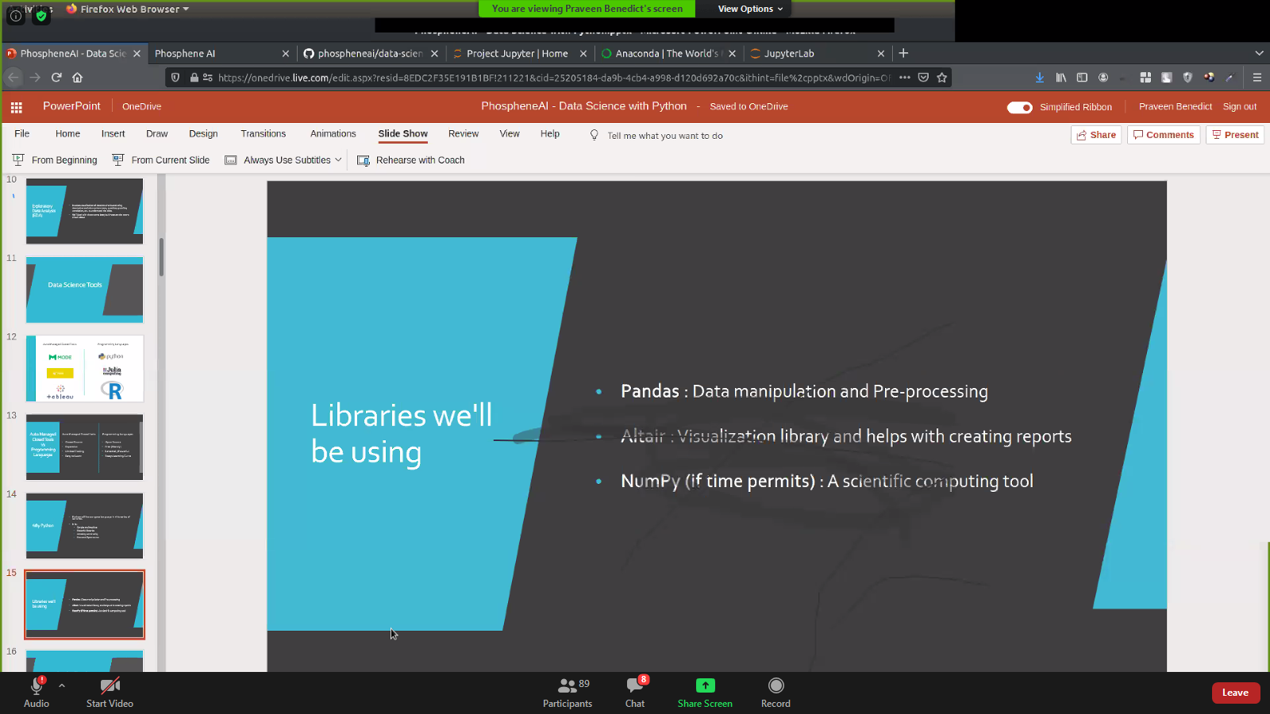

**Completed RPA COURSE:**

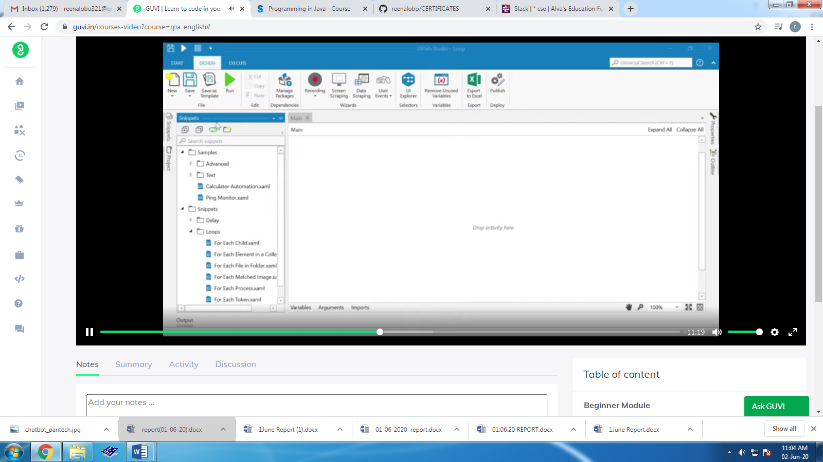

**CODING CHALLENGE:**

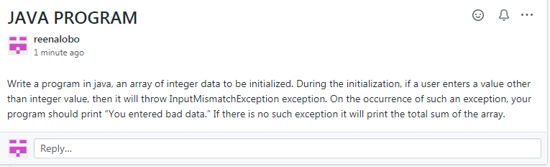

STUDENTS REPORT:

**RAVALI:**

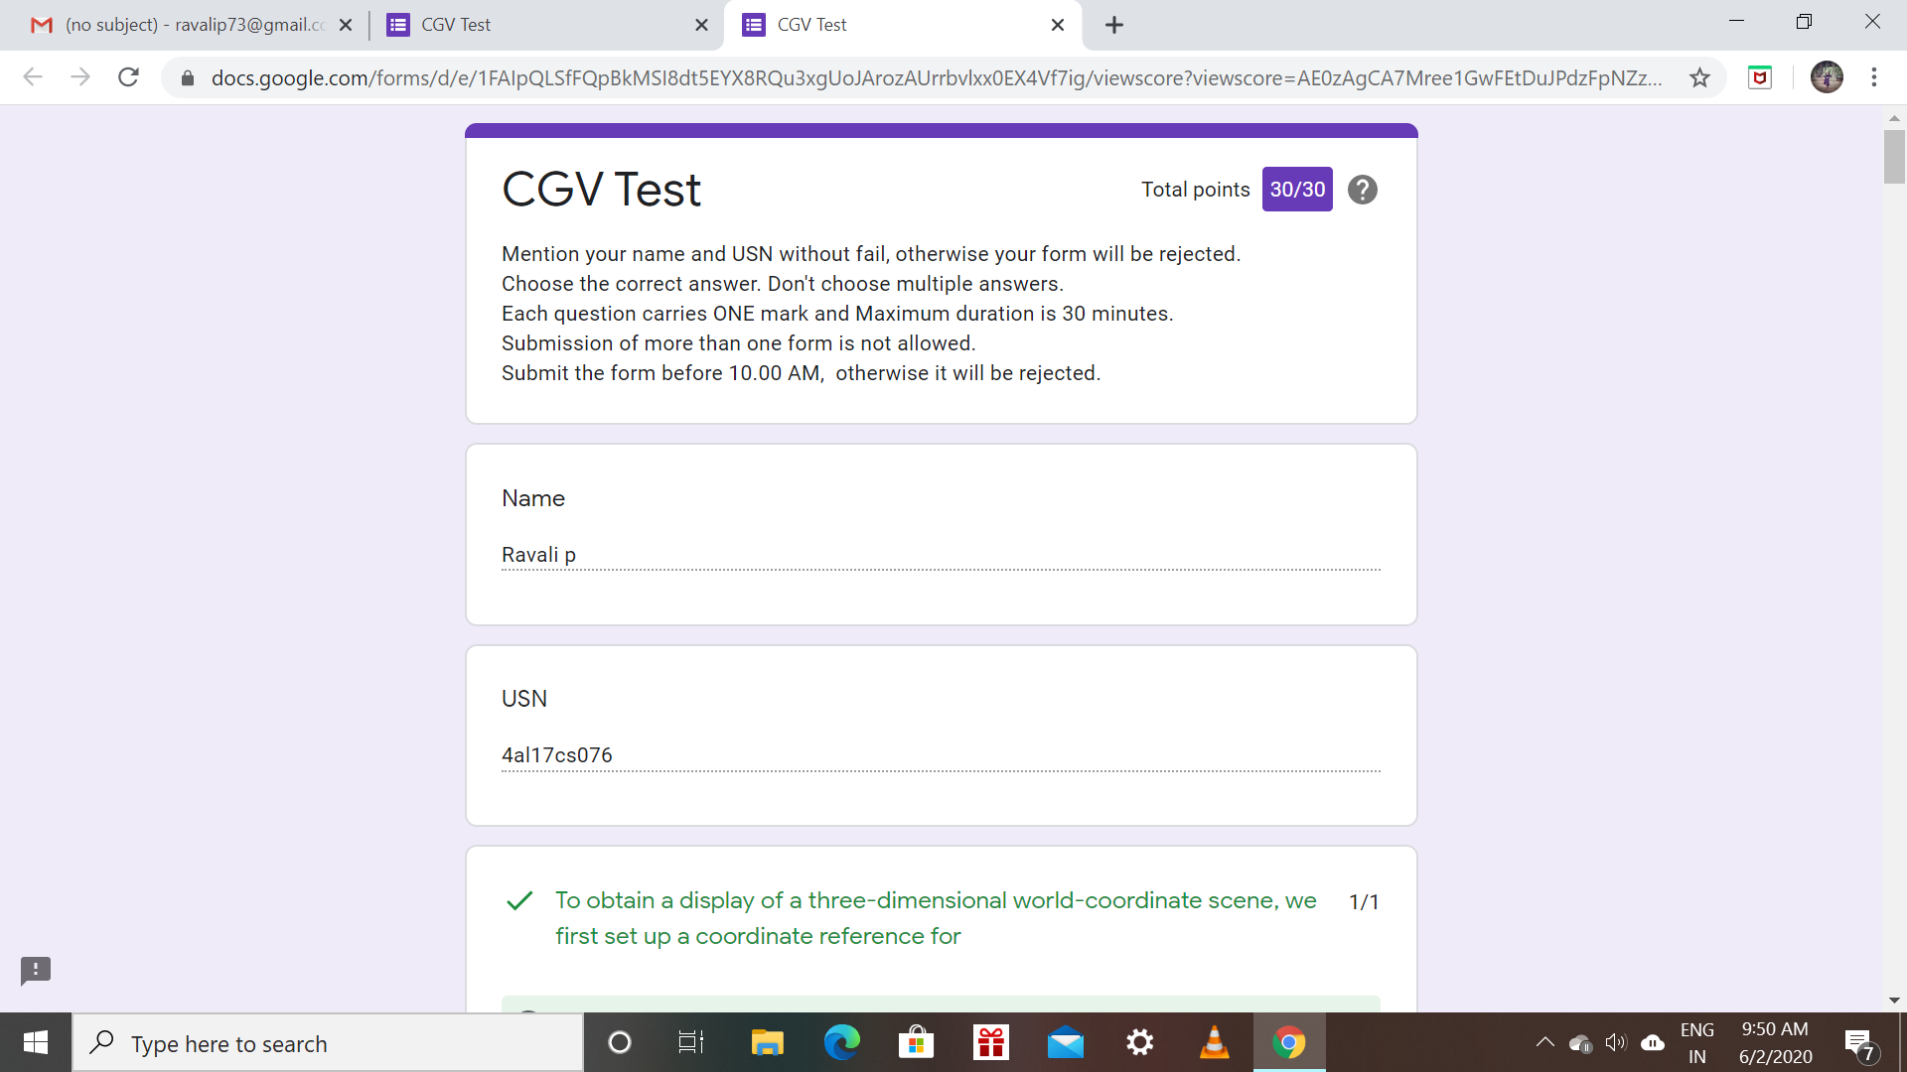

Certification Course Details: (Attach the snapshot and briefly write the report for the same)

* Todays topic on python for data science is about python data structures.It includes about list ,tuples,sets and dictionaries.

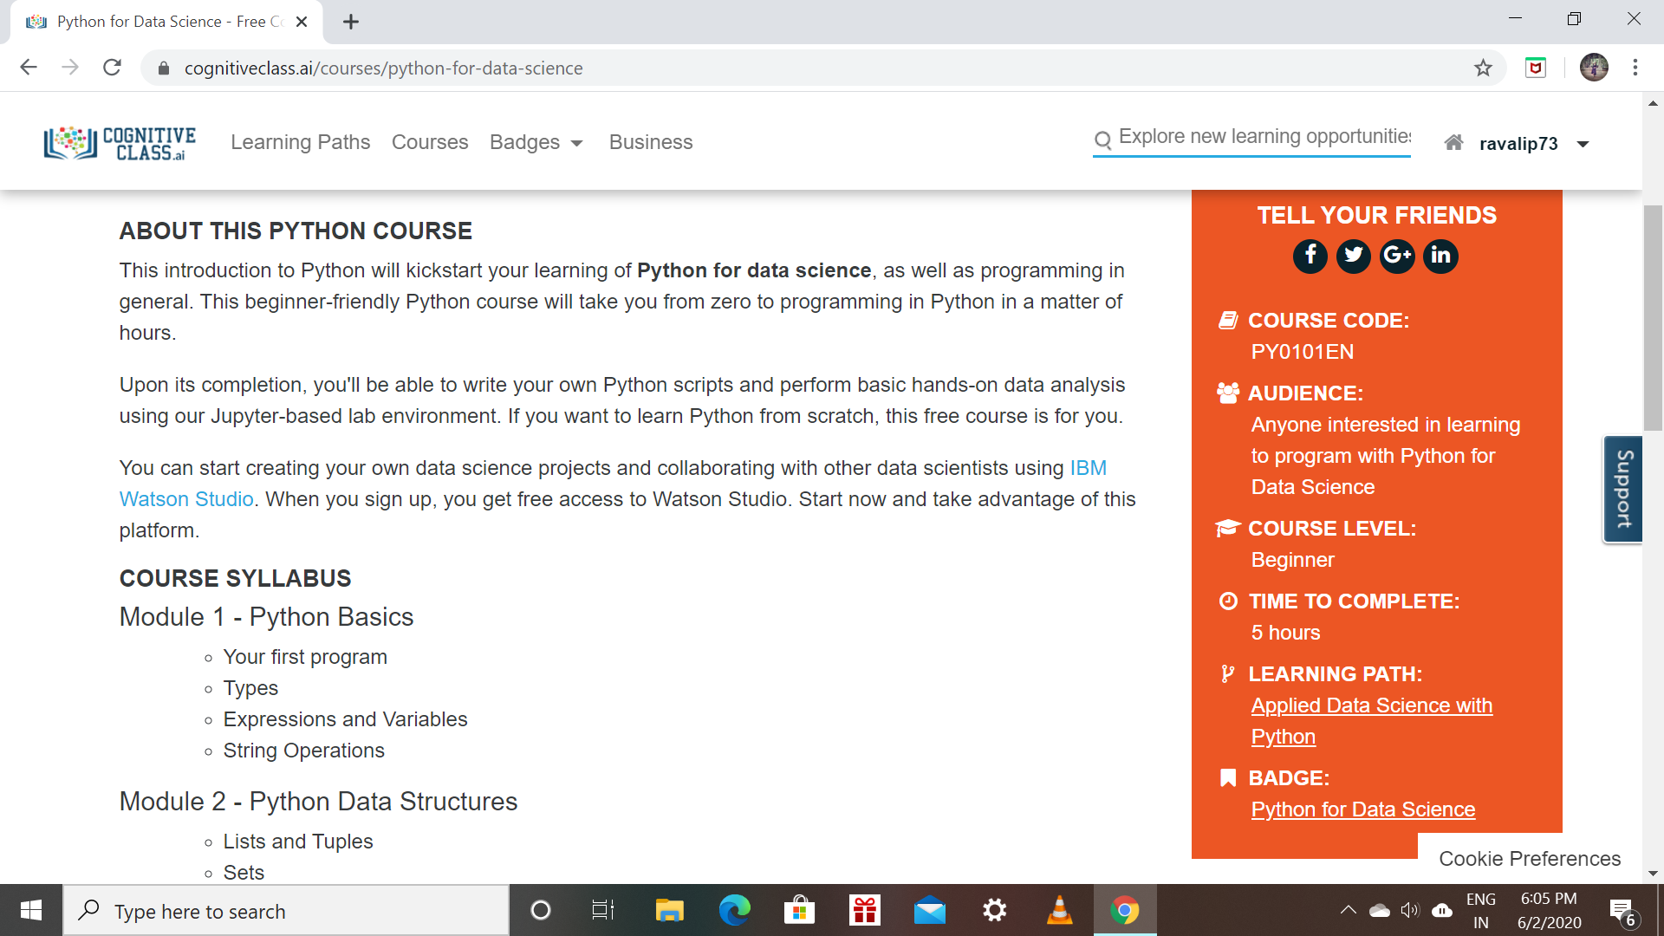

**RAKSHA:**

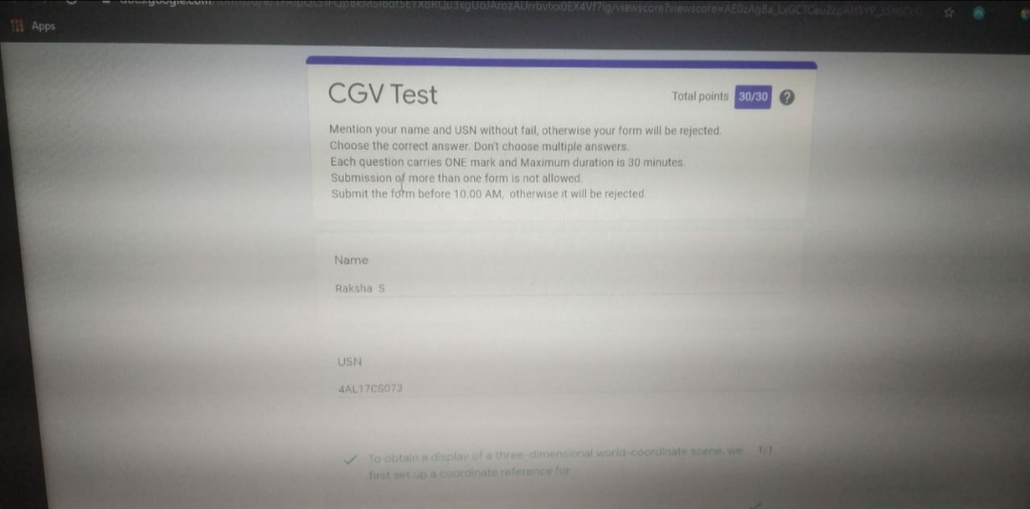

Scored 30 out of 30 in CGV 2nd I.A test

Certification Course Details:

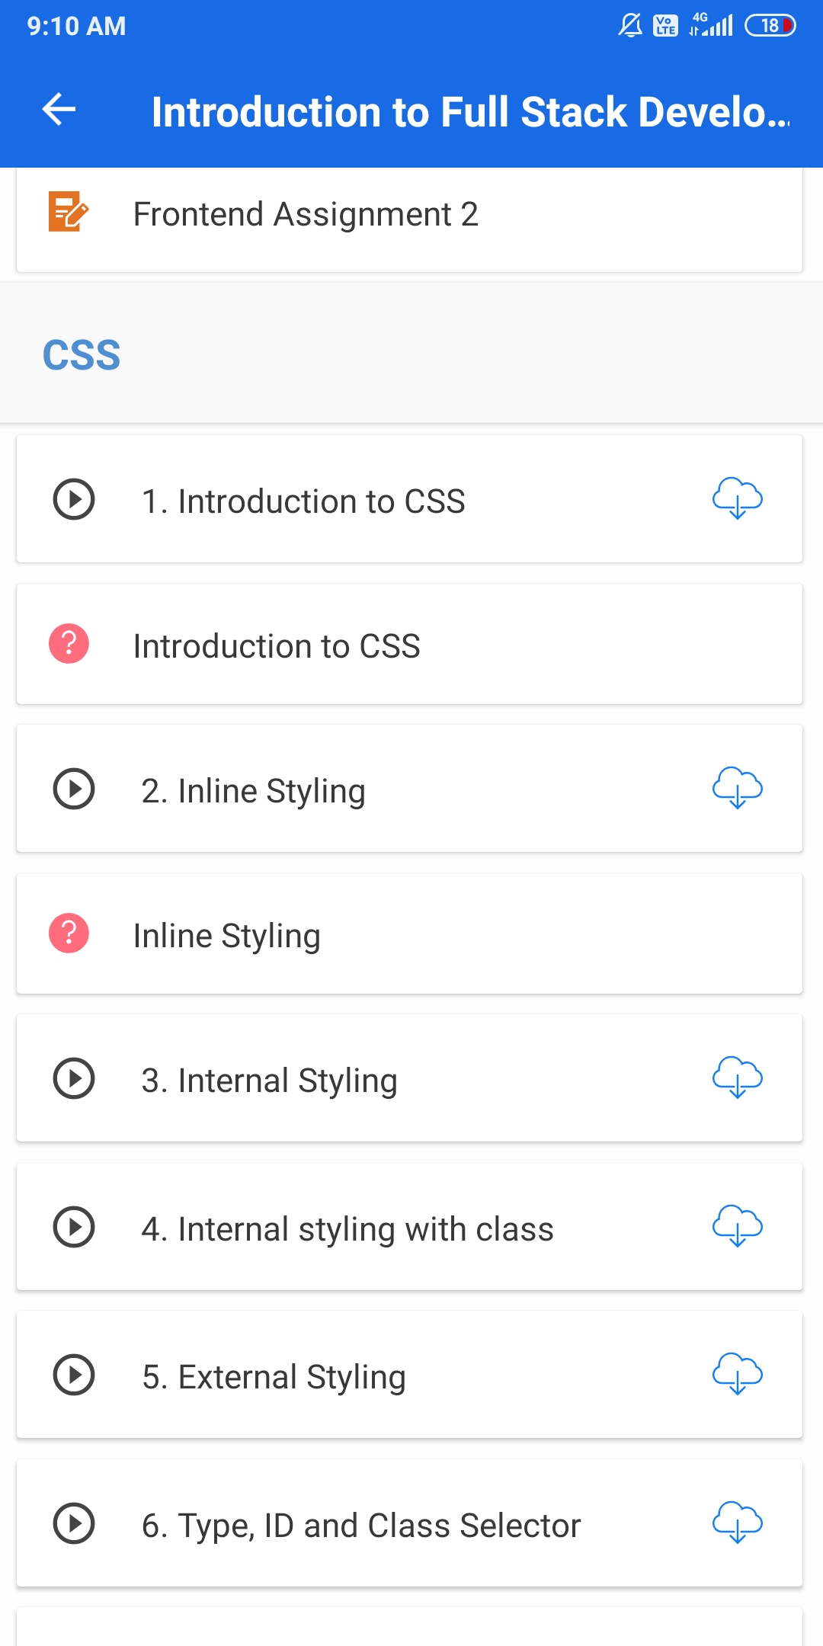

ROHAN MAHAVEER:

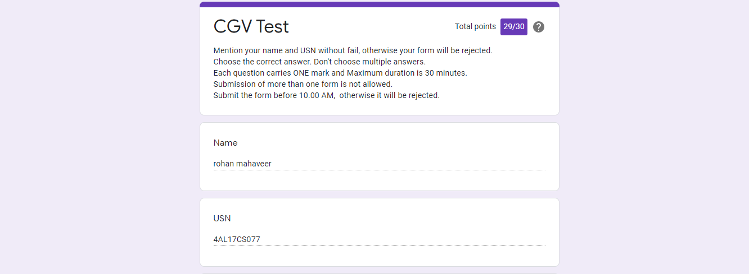

Scored 29 out of 30 in CGV 2nd I.A test

Certification Course Details:

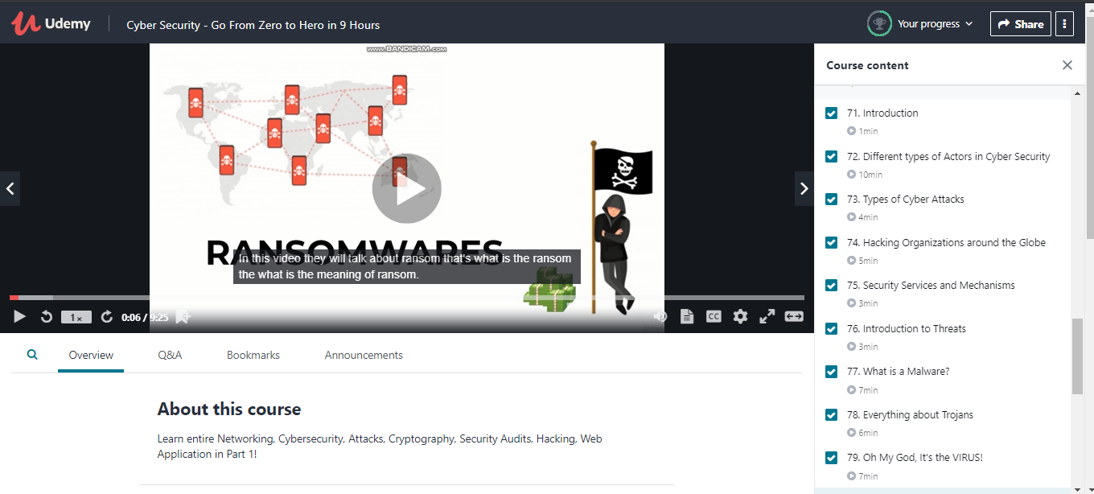

PREETHI:

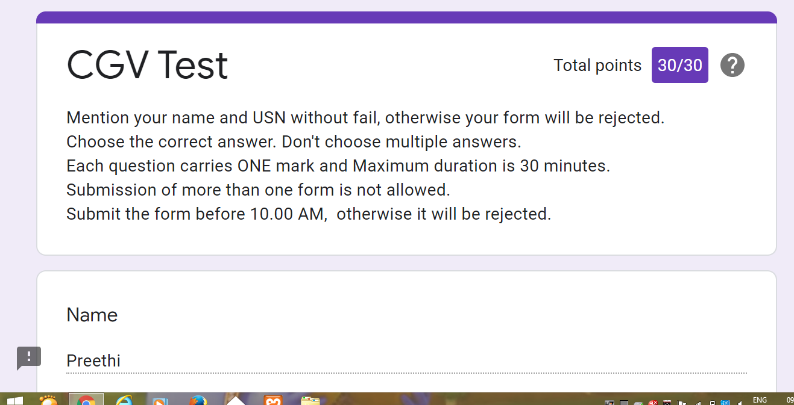

Certification Course Details: (Attach the snapshot and briefly write the report for the same)

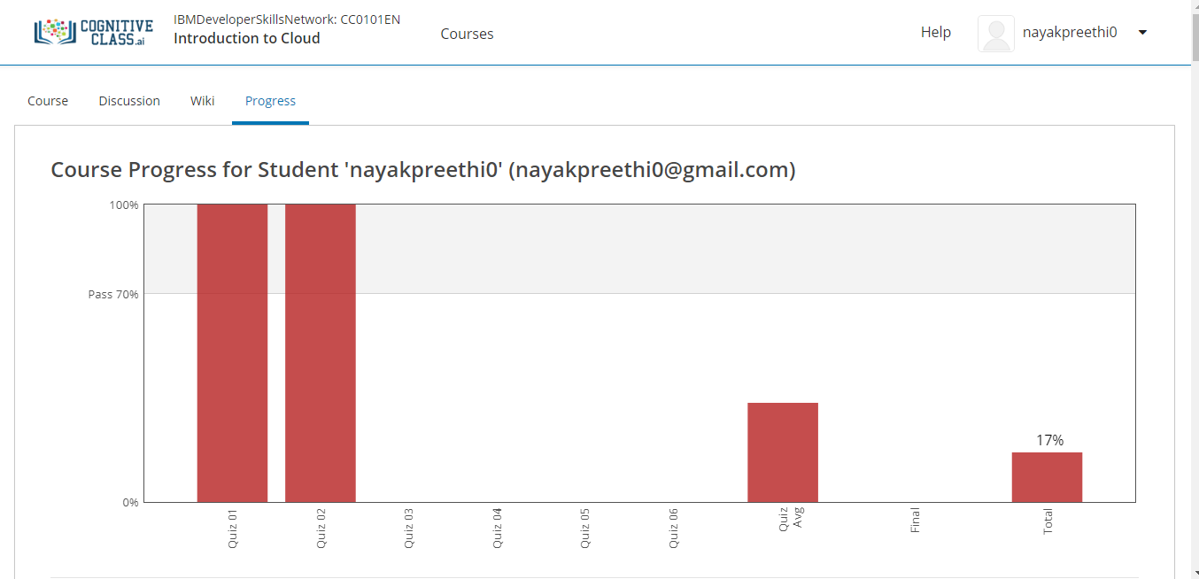

PRANAV L M:

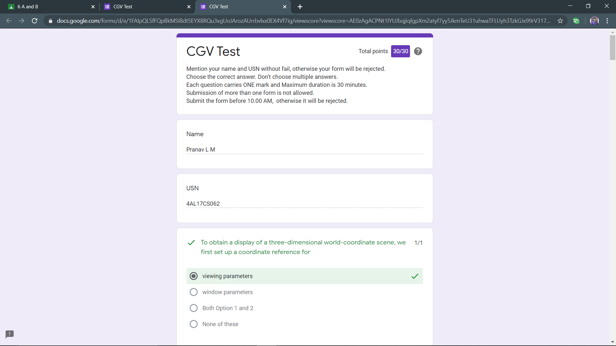

CERTIFICATION DETAILS

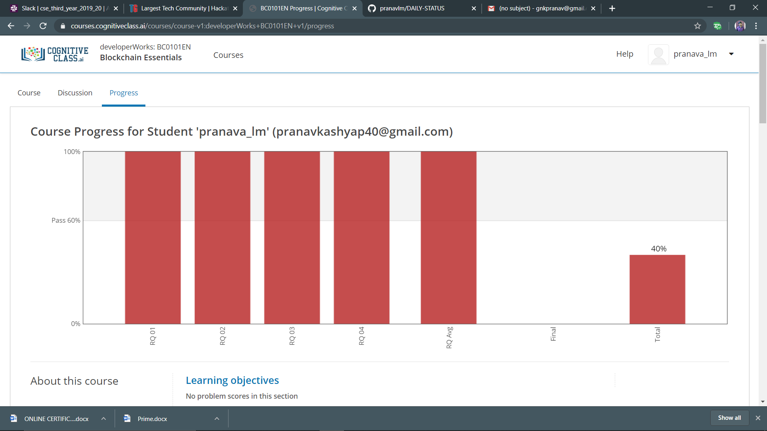

P-1

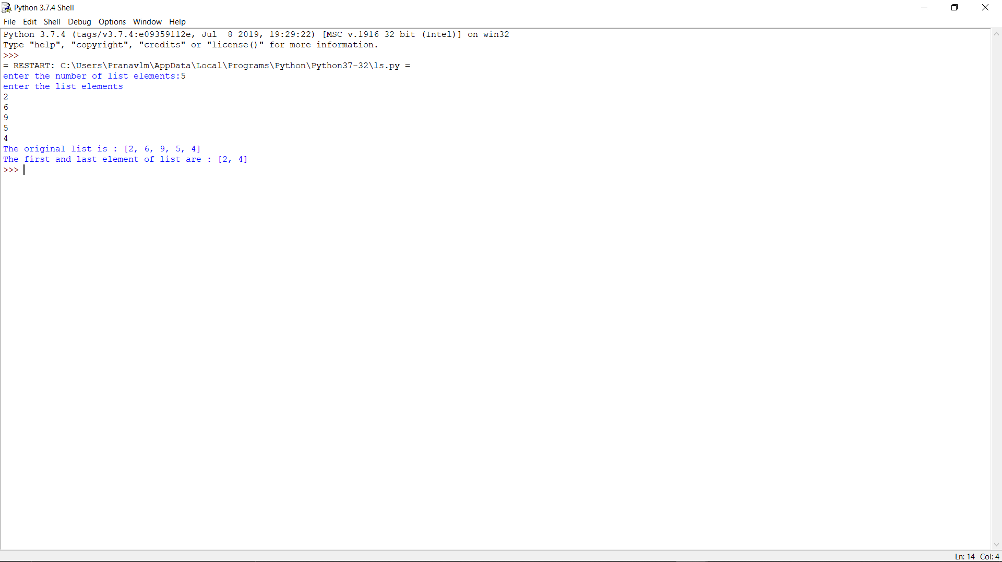

RANI:

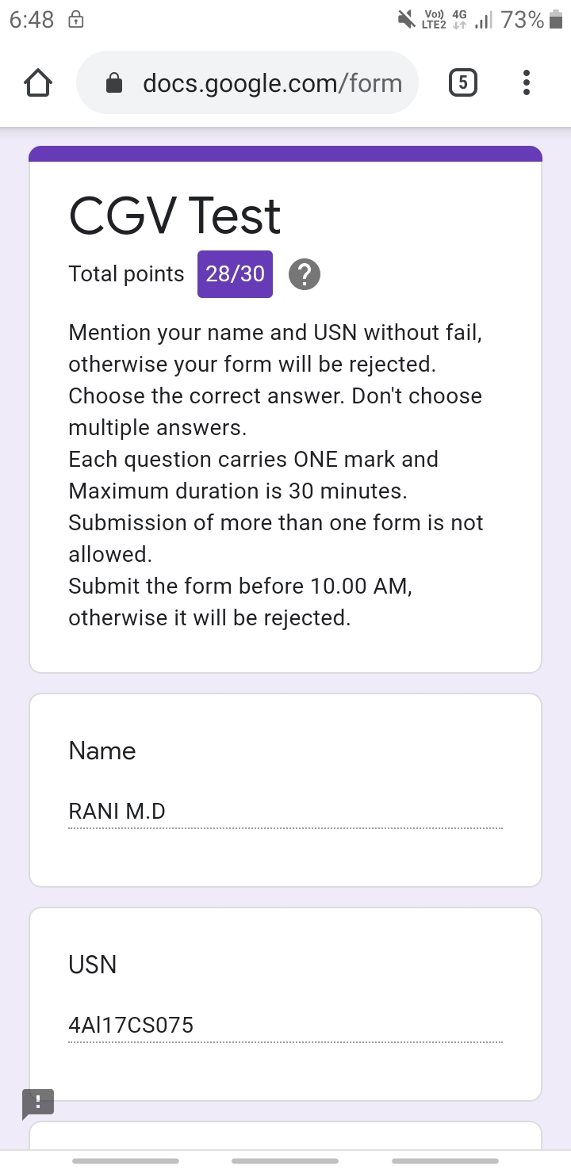

RACHANA K N:

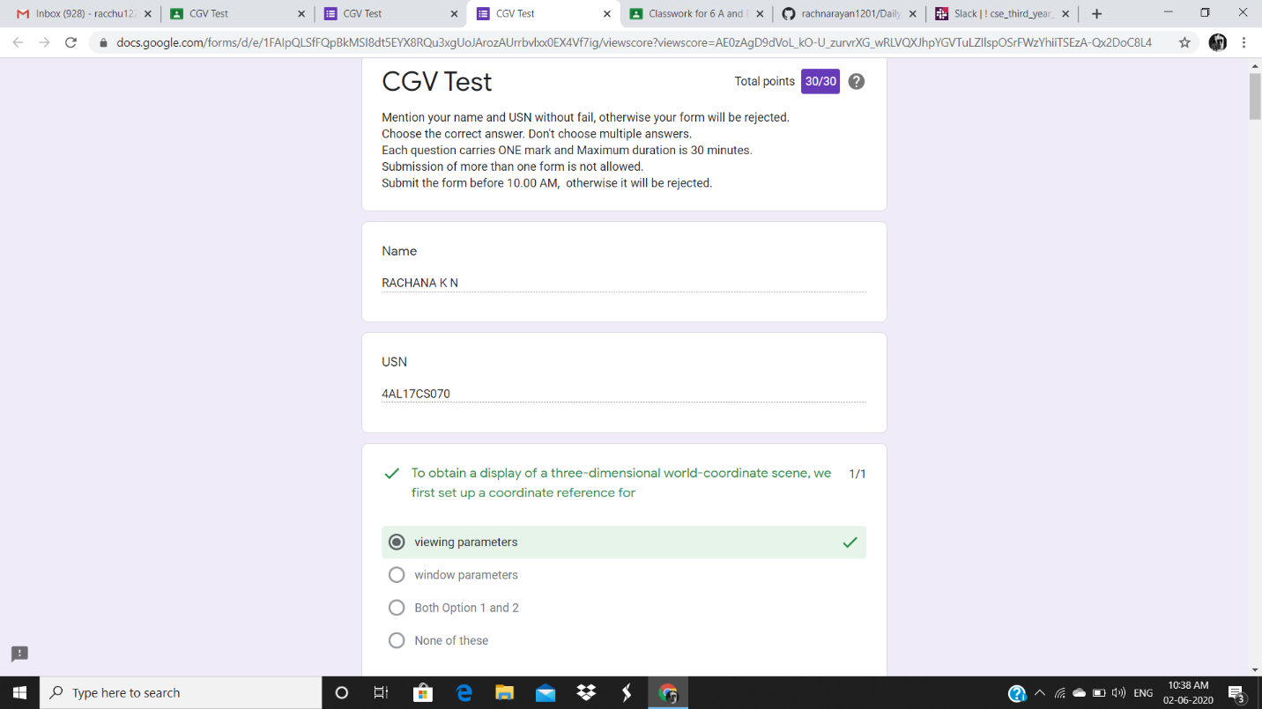

**Certification Course Details:**

**Today Progress:**

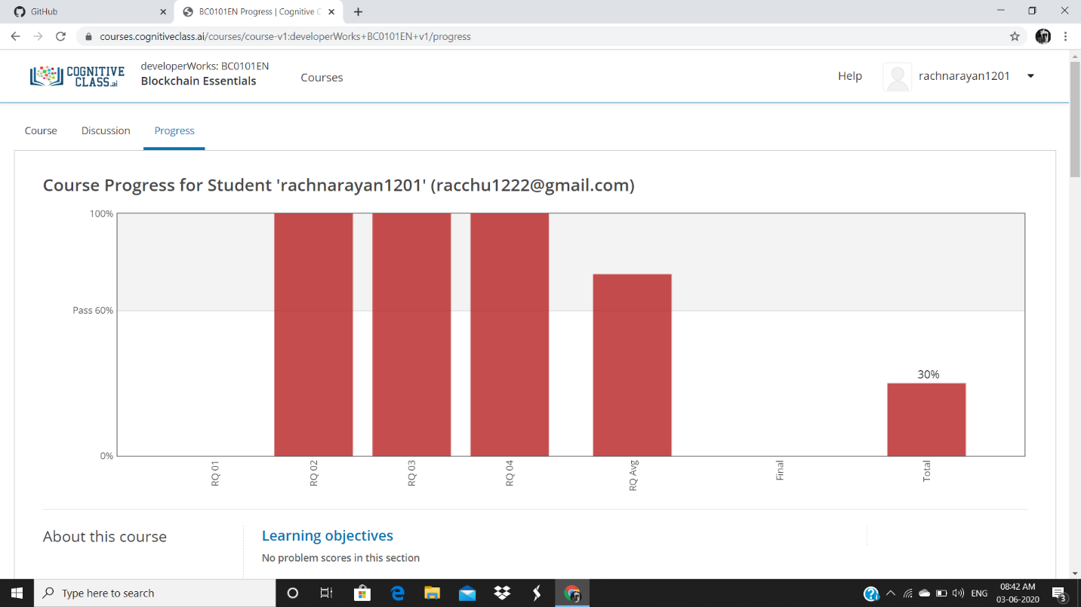

Completed the review questions of all modules(4 modules).

**Coding Challenges Details:**

Refer the github link for detail information :https://github.com/rachnarayan1201/daily_status_coding/commits?author=rachnarayan1201

Solved all the problems and the solutions are uploaded in github account.

PRIYANKA:

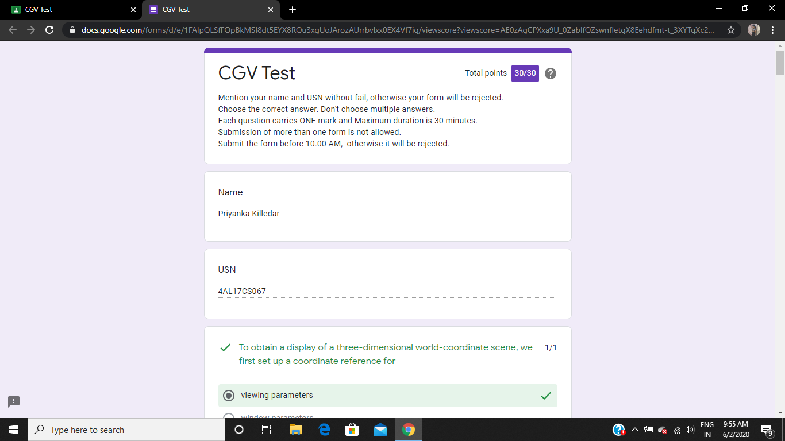

**Certification Course Details:**

**Today Progress:**

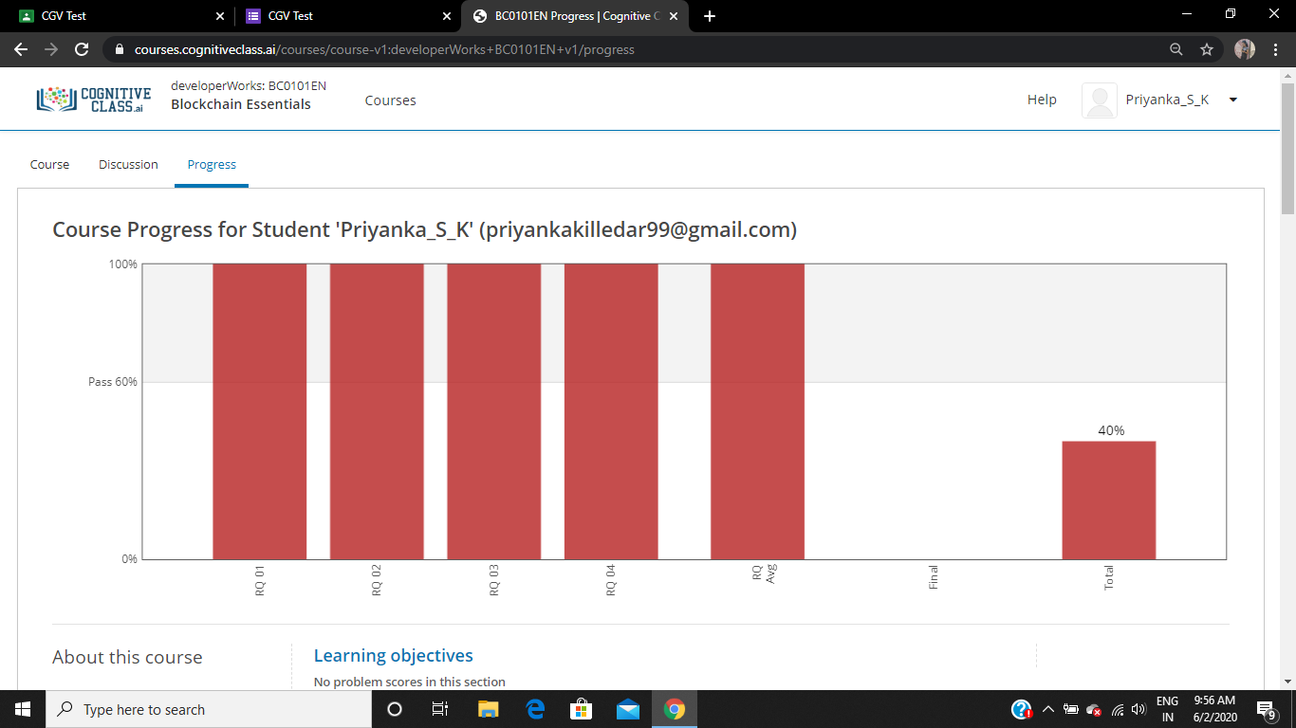

Completed the review questions of demo part and pasted the progress report.

**Coding Challenges Details:**

Refer the github link for detail information :<https://github.com/Priya-s-k/Online-coding-updates>

Solved all the problems and the solutions are uploaded in github account.

SANA:

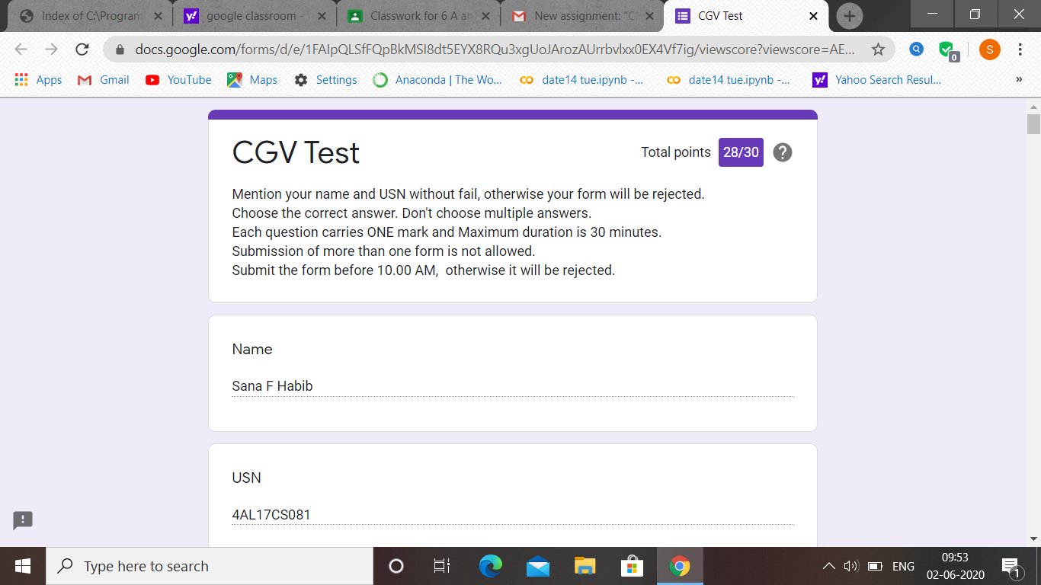

CGV test was held today in google classroom i.e 2 June 2020. Out of 30 marks I scored 28.

Certification Course Details: (Attach the snapshot and briefly write the report for the same

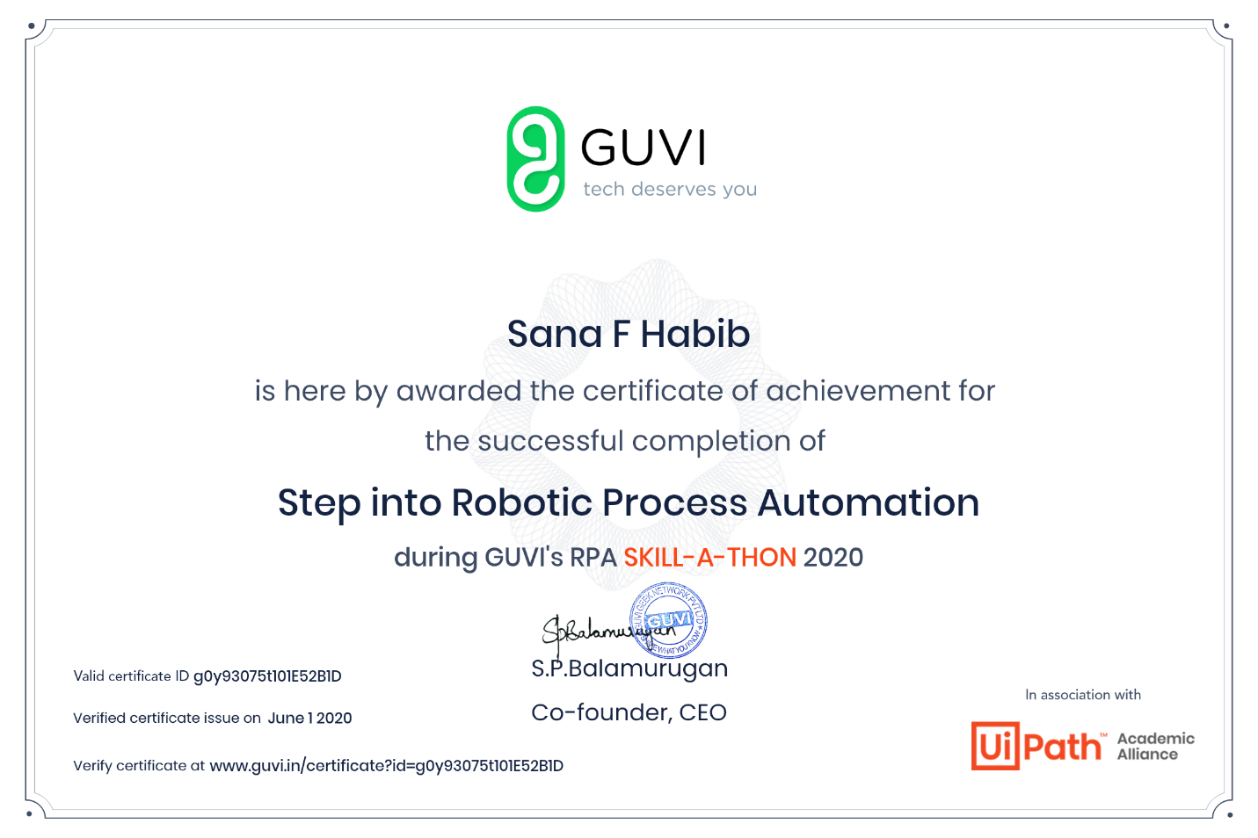

ATISH:

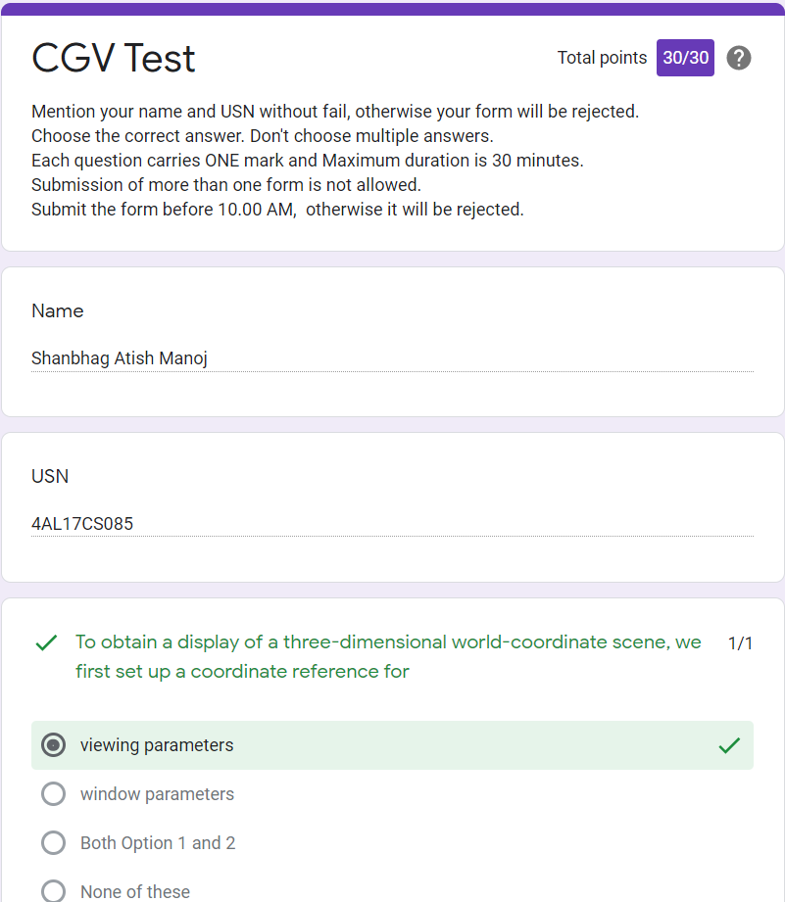

Certification Course Details:

Report

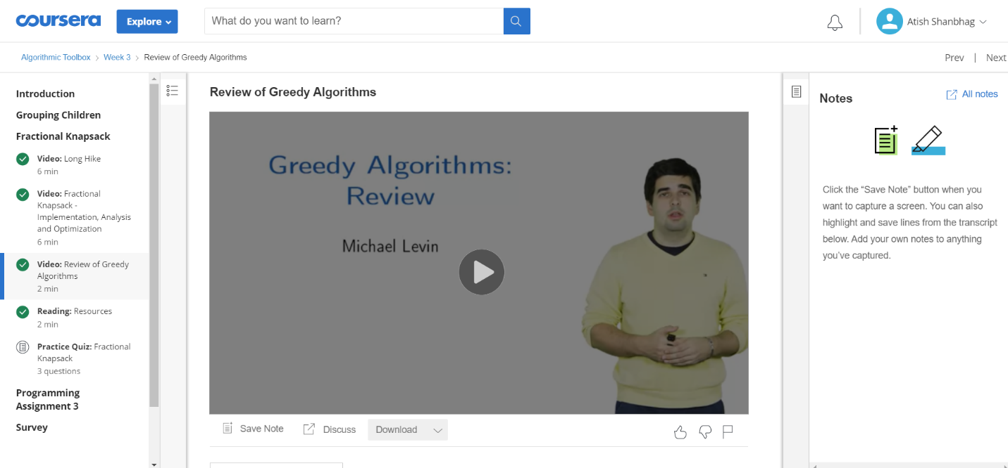

DRUVIL:

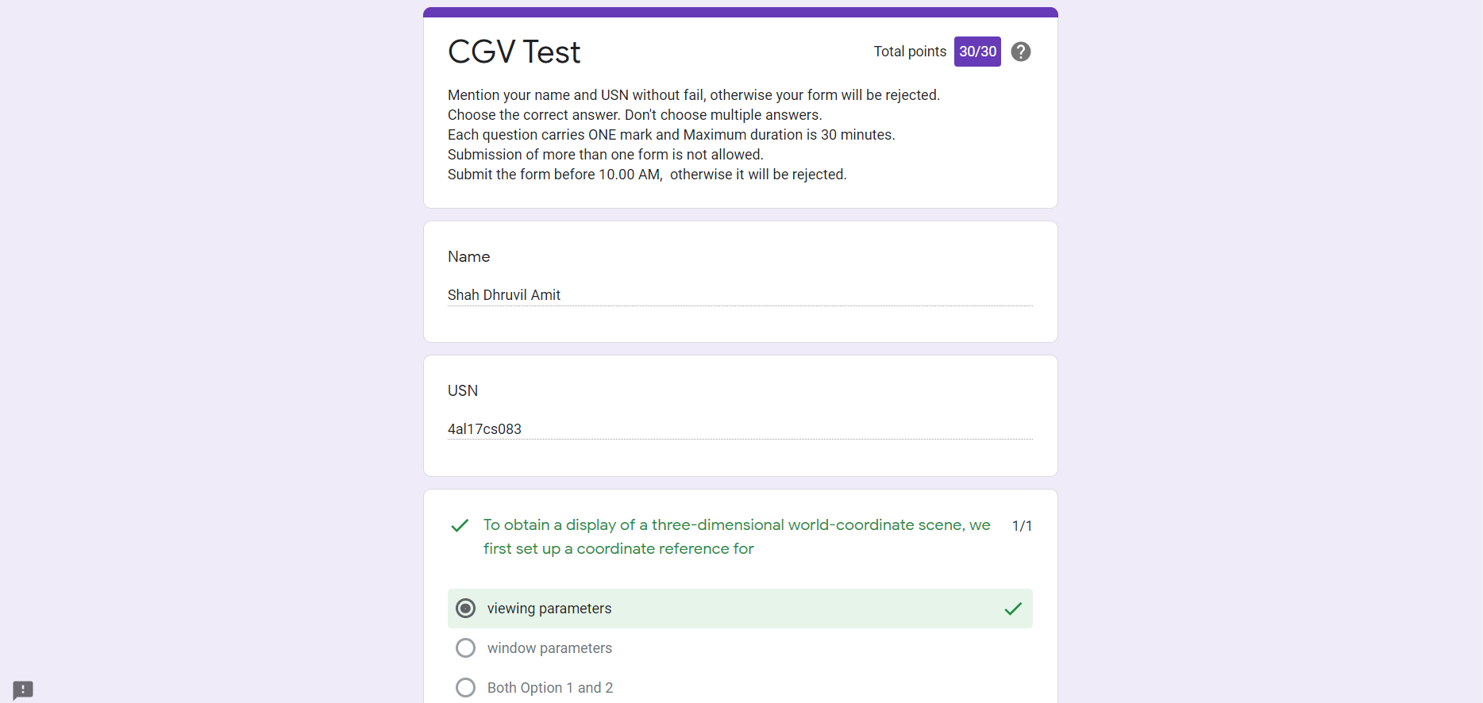

Certification Course Details:

Report

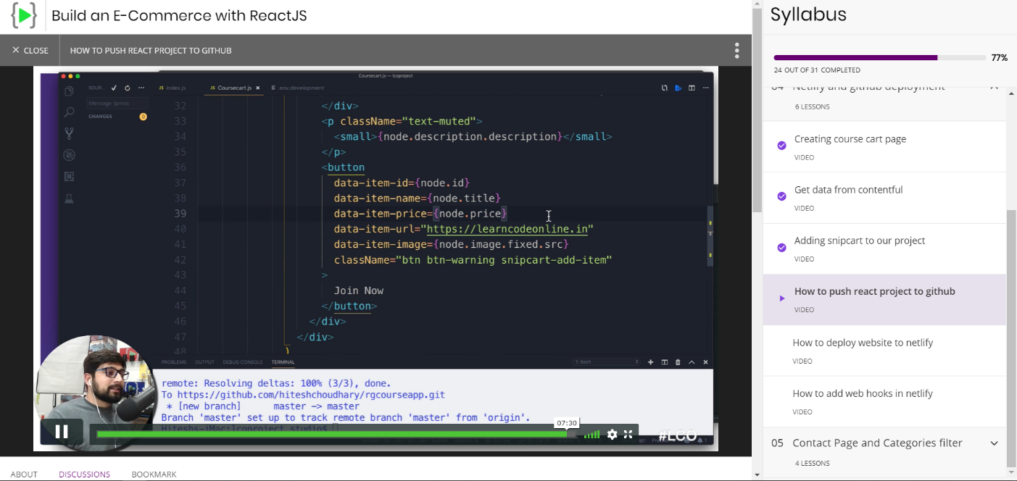

In today online certification session, I have learned to add snipcart to our project and also how to push the project onto github.

Coding Challenges Details:

The below GitHub link for details

<https://github.com/DhruvilShah99/Daily-Updates>

PRIYA H T:

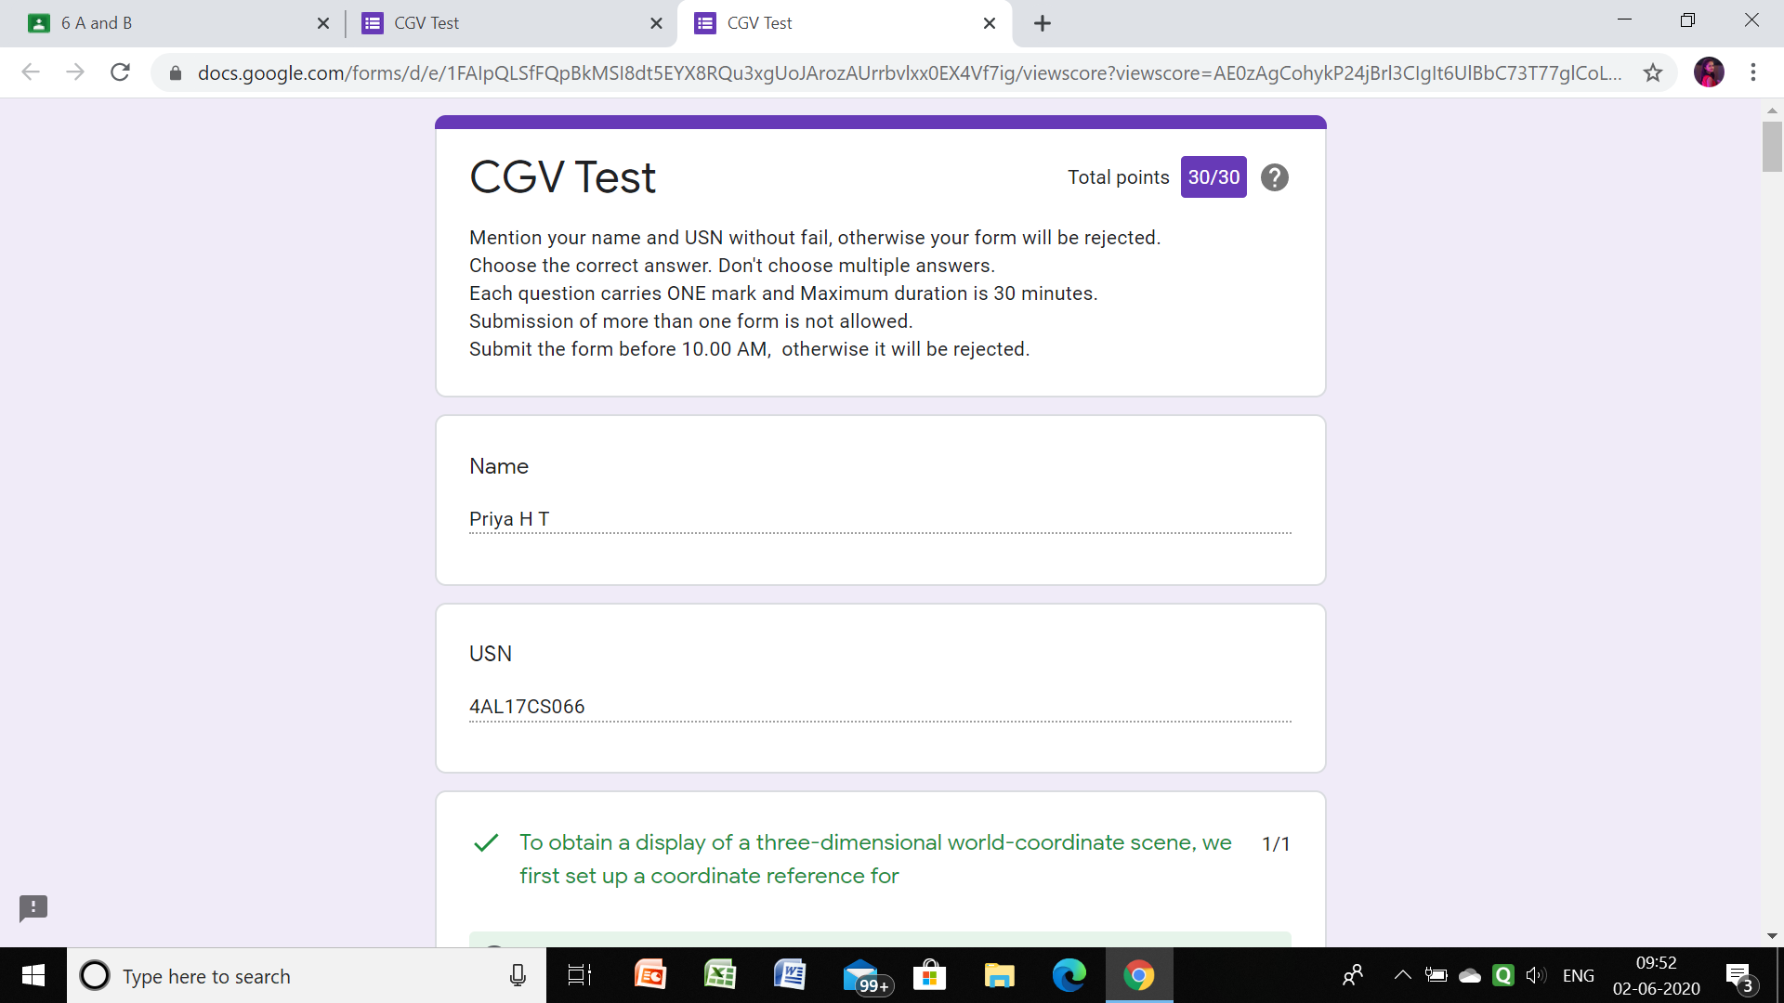

**Certification Course Details:**

Github link for information: <https://github.com/priya3028/Daily-status>

**Topics completed today:**

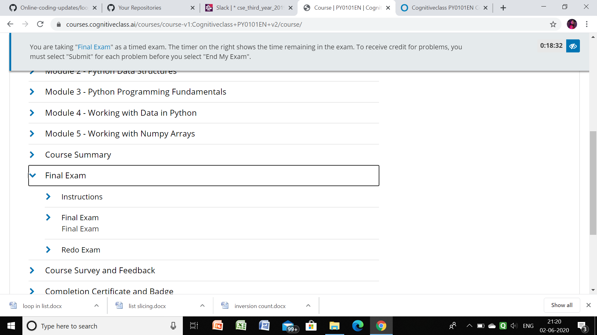

ROHAN VASISTA:

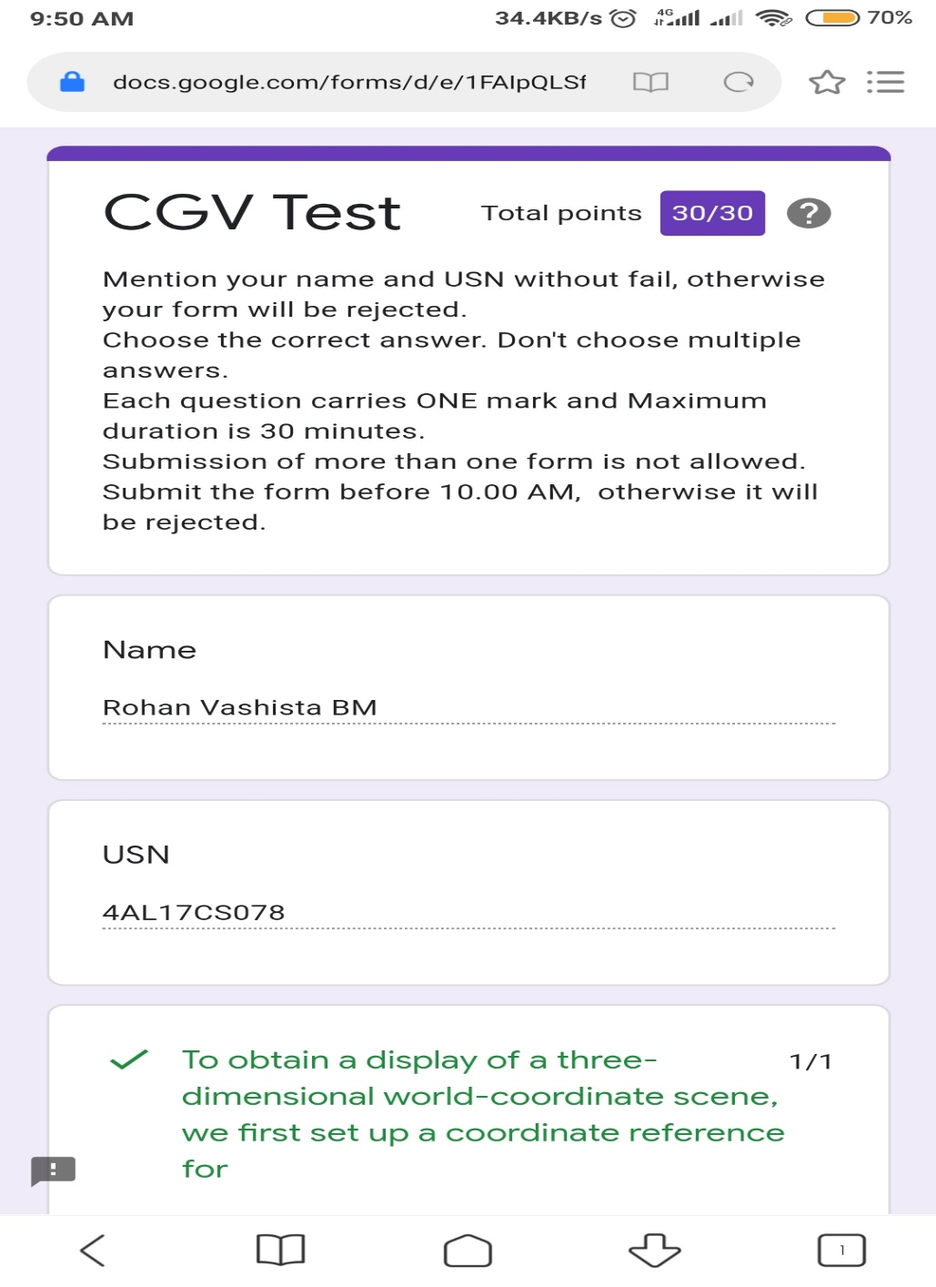

PRAVEEN KUMAR:

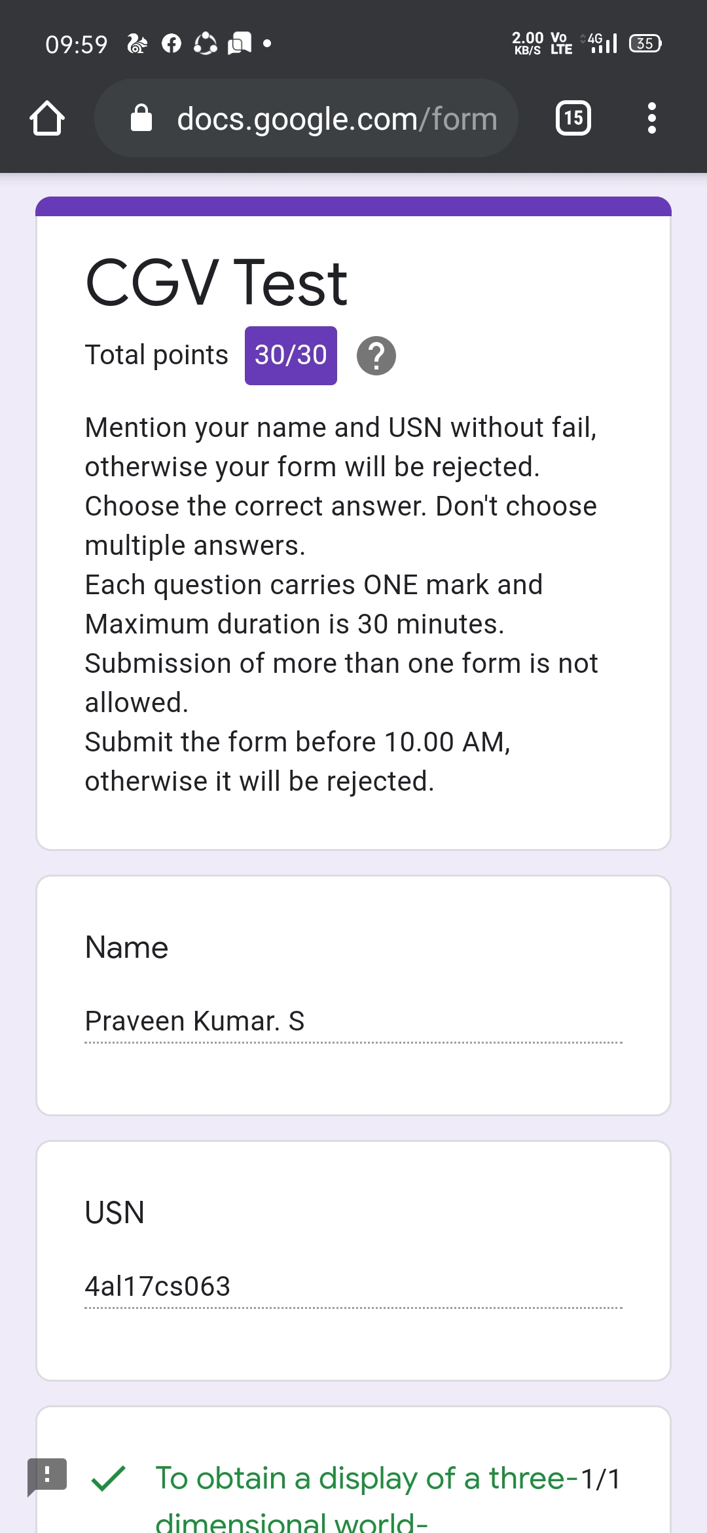

certification course snap

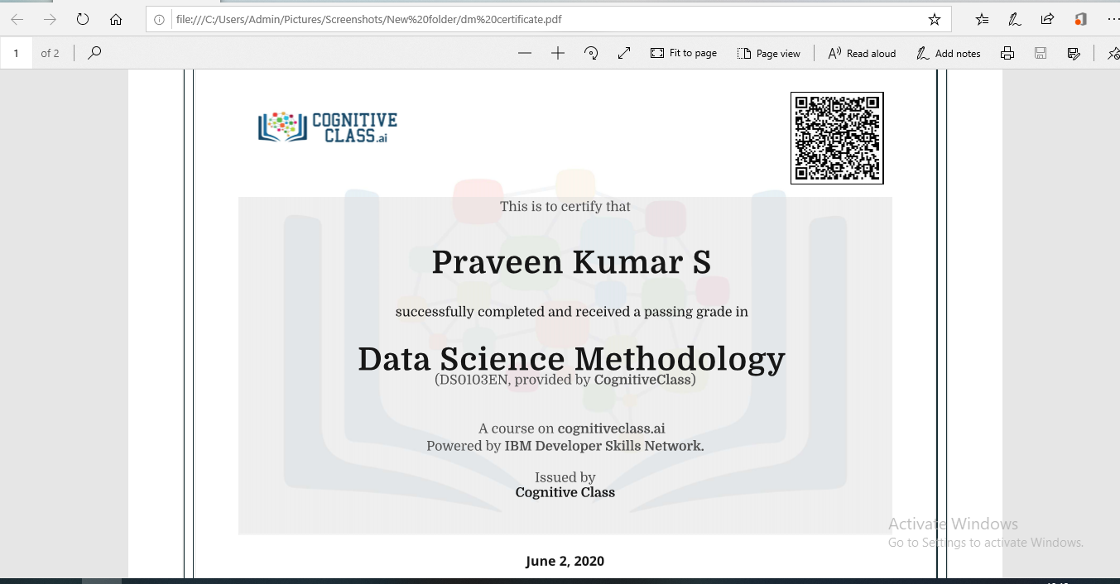

RAGHAVI:

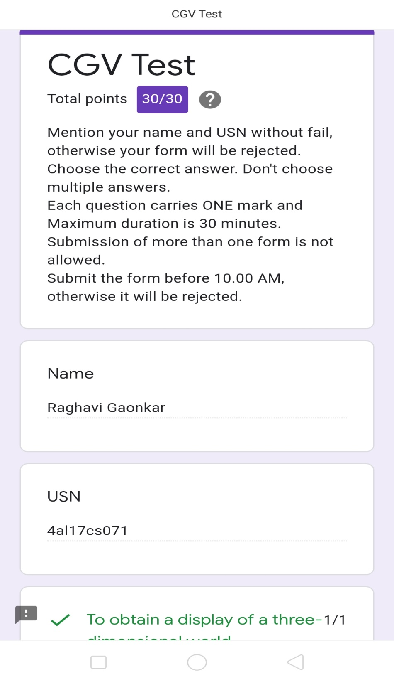

Certification Course Details:

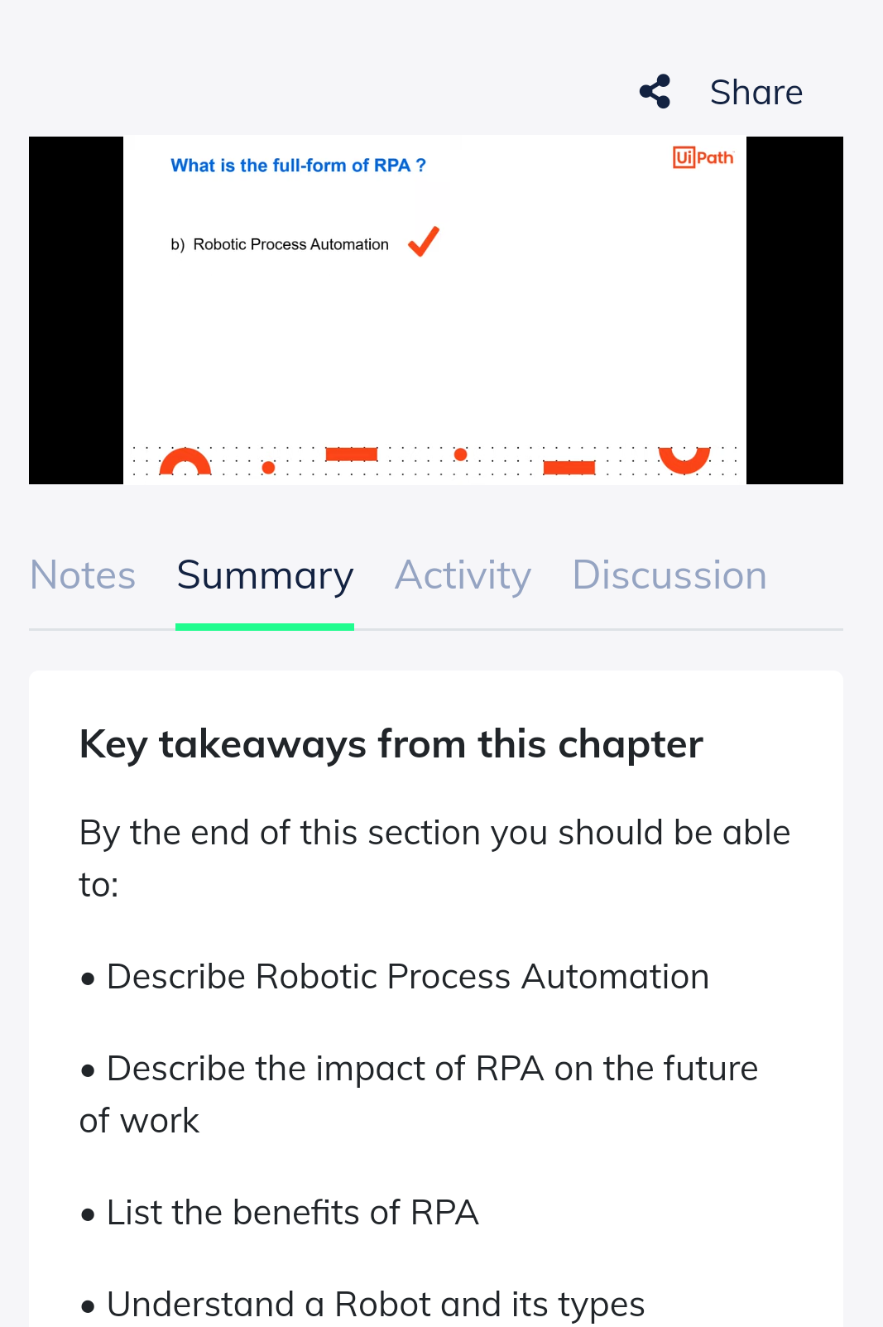

ROUSHA:

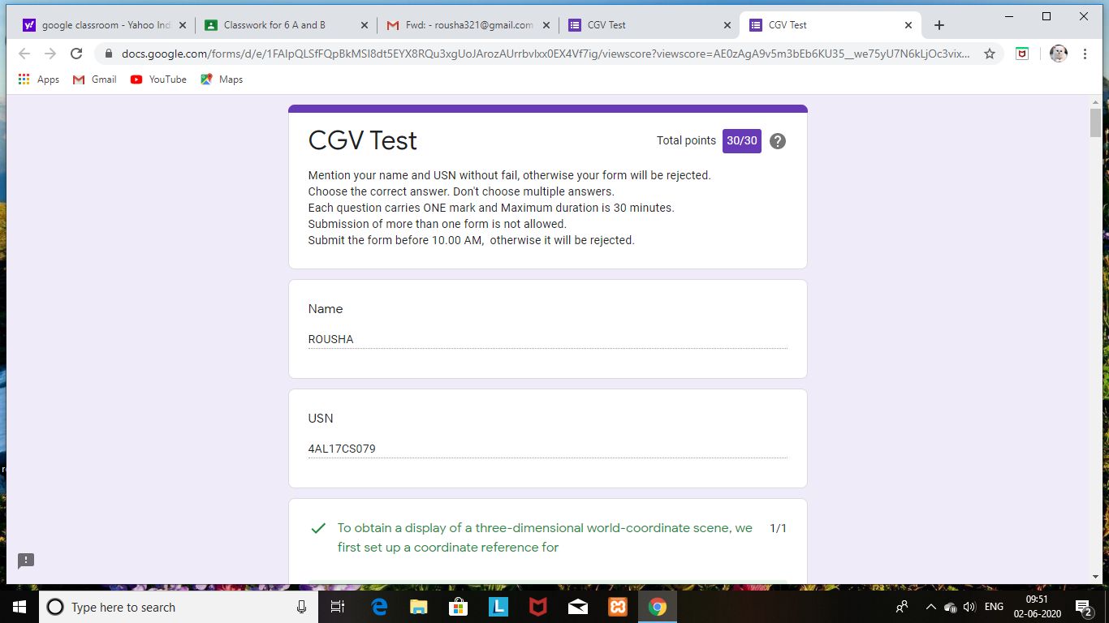

Certification Course Details: (Attach the snapshot and briefly write the report for the same)

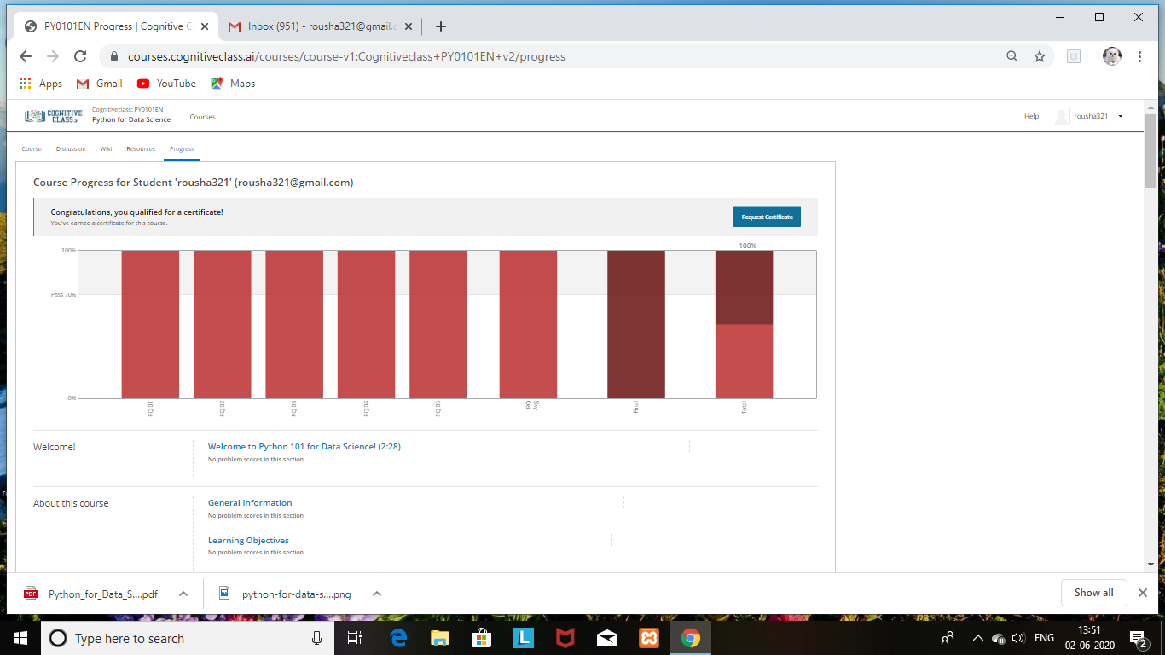

SHAIFA:

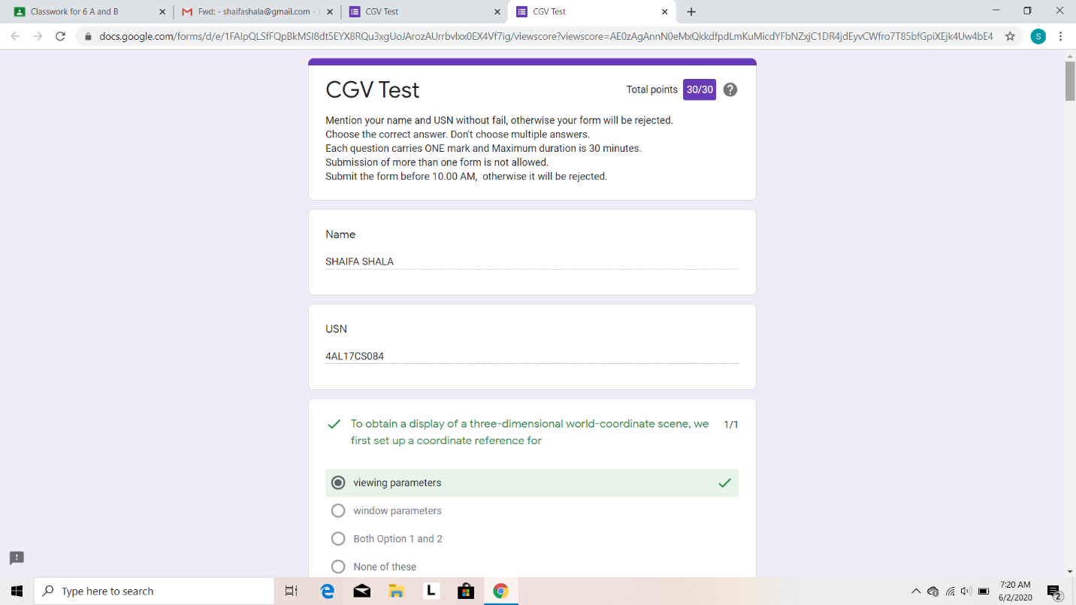

Certification Course Details: (Attach the snapshot and briefly write the report for the same)

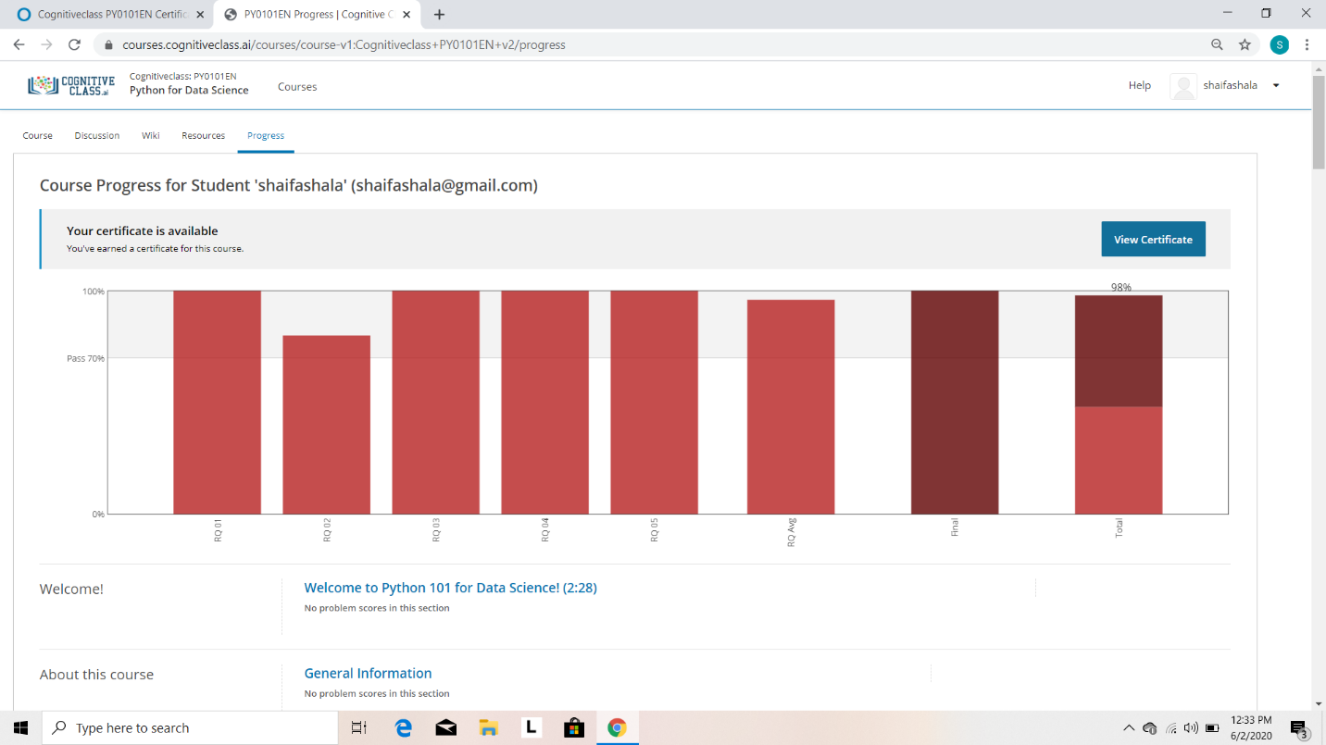

SACHIN:

